Screenshots of ORM and Spring MVC assignment

By

Vyanktesh Mishra

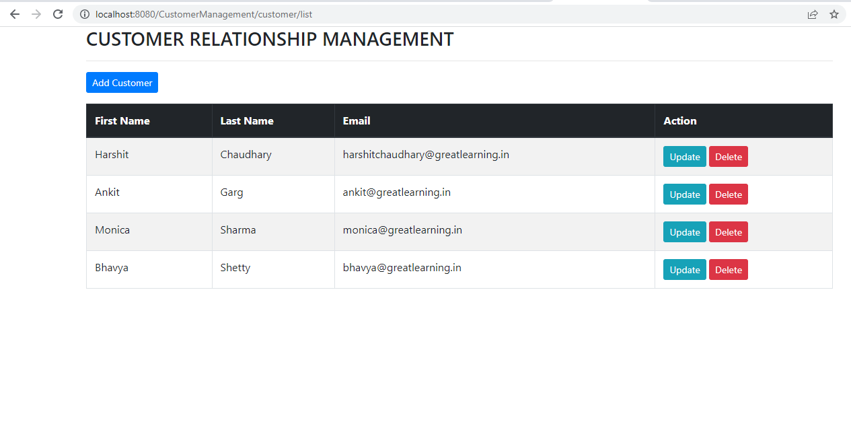

The above is a sample template of the main page

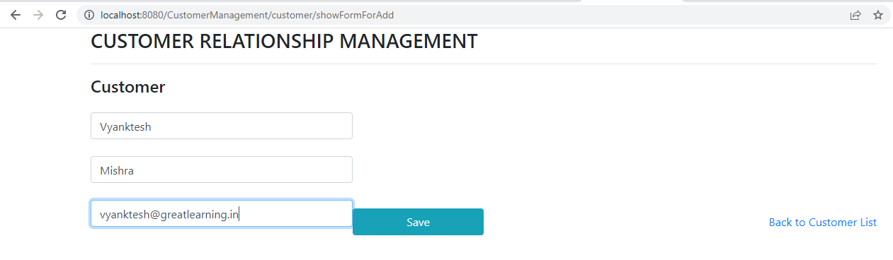

Upon Click Add Customer button user will be redirected to a new form page, wherein the user will enter details and save.

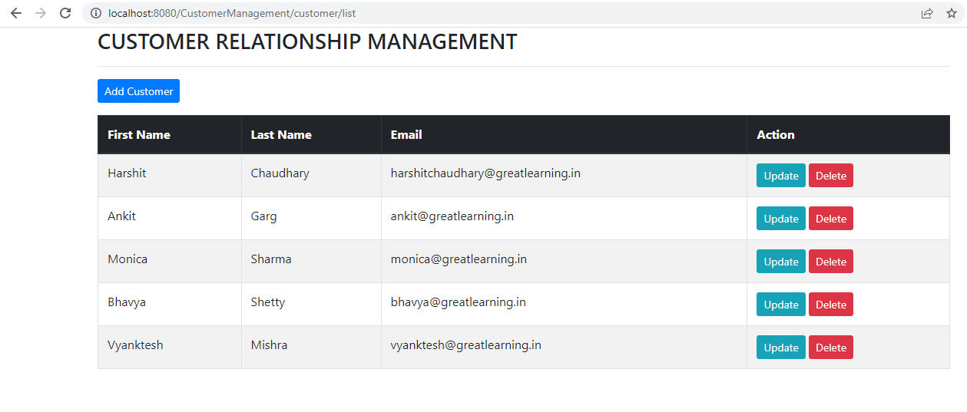

Updated list of customers after adding a new customer Vyanktesh Mishra.

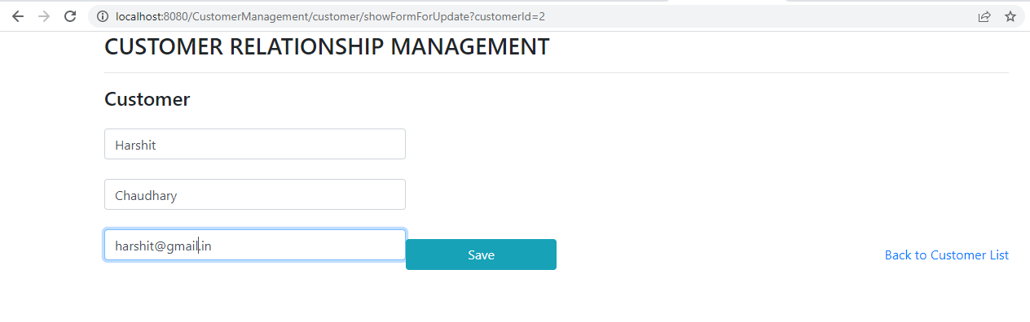

Updating the email address for customer Harshit Choudhary and saving it with address gmail.com

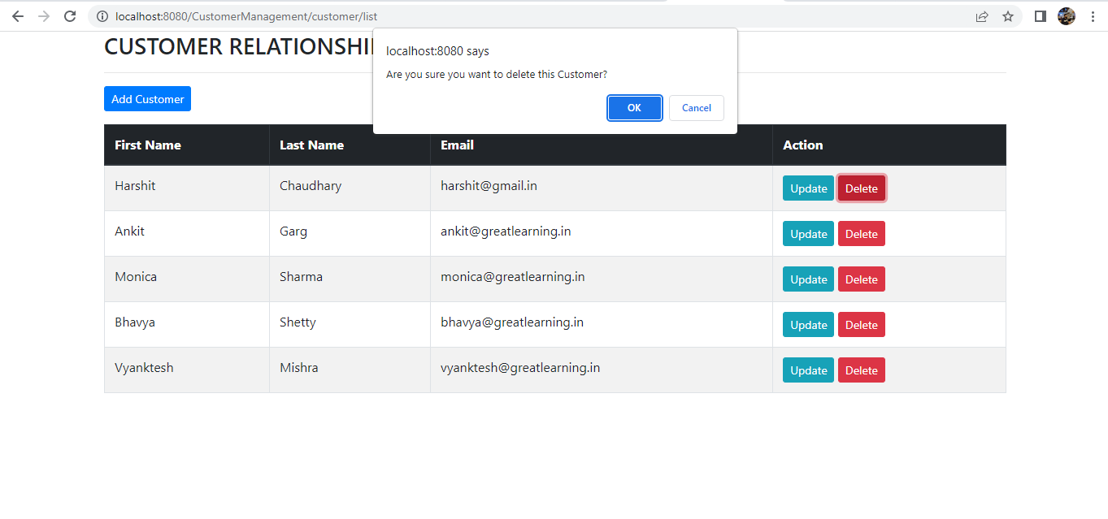Updated value of Customer Harshit Choudhary with email address ending with gmail.com, also upon clicking the delete button, a pop up is generated.

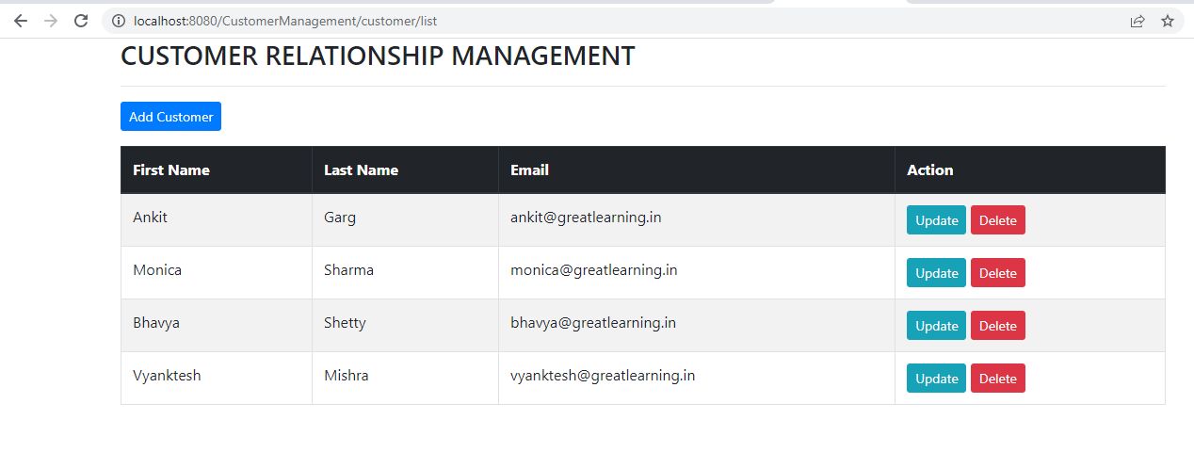

Updated list of employees upon deleting customer Harshit Choudhary

\*\*\*\*\*\*\*\*\*\*\*\*